Calculating Daily Returns - Explanation
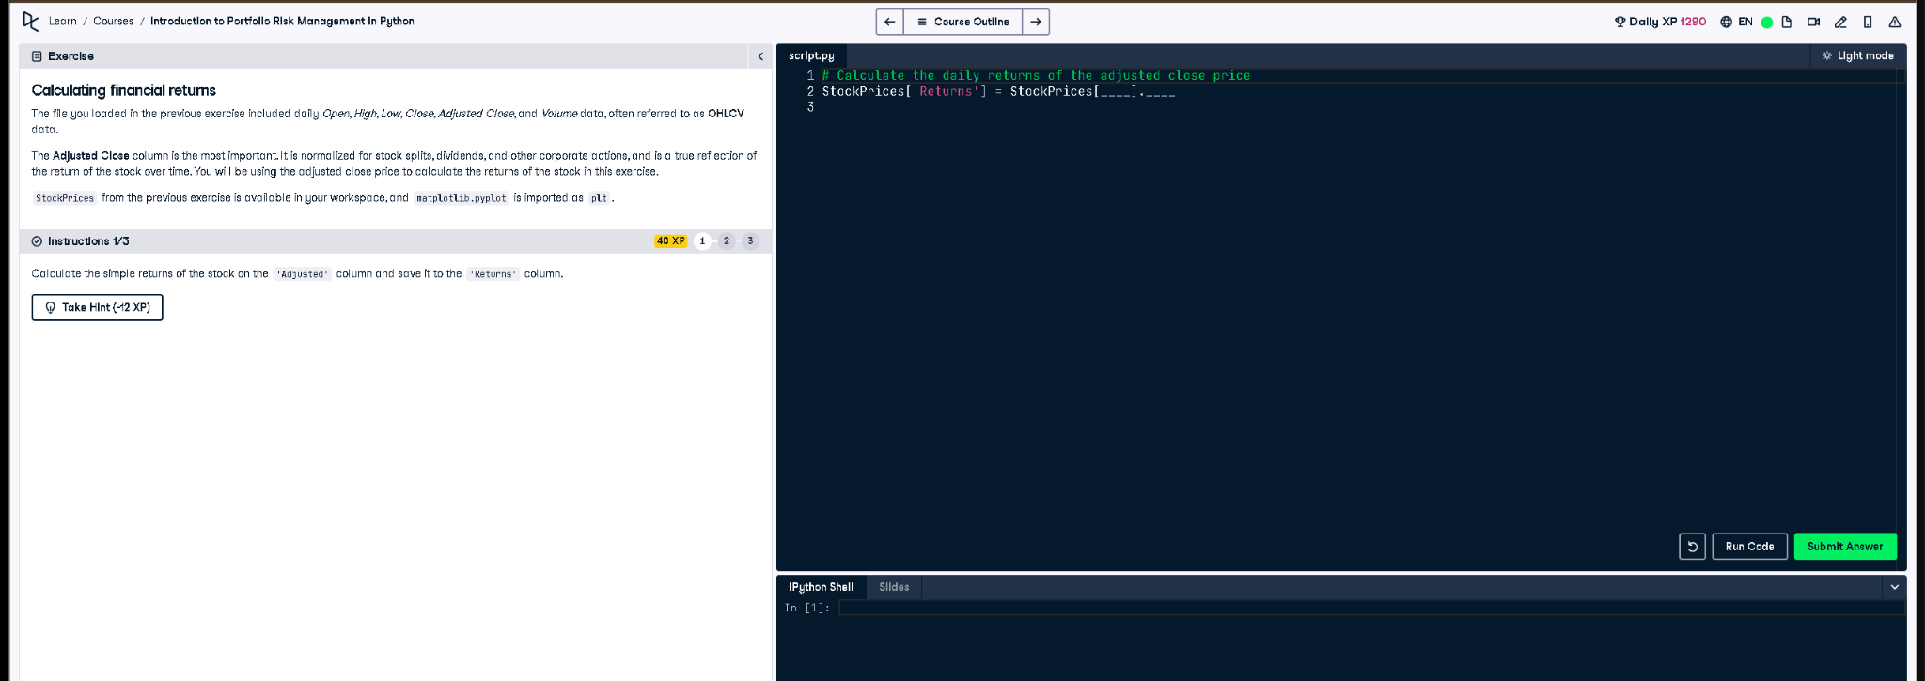

Python Code
# Calculate the daily returns of the adjusted close price
StockPrices['Returns'] = StockPrices['Adjusted'].pct_change()

Explanation (in simple words)
This code calculates the stock’s daily simple return using the 'Adjusted' column. It uses the .pct_change() function to get the percent change from one day to the next, and stores the result in a new column called 'Returns'.

